Instructions to run Stock Management Portfolio

**Prior Installation requirements:**

1. Install pip and upgrade to most current version

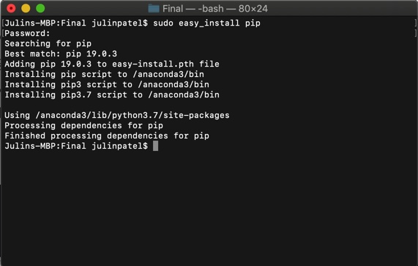

1. Install robin-stock via pip

**Running Stock Portfolio Manager**

1. Open terminal and move to directory with program and run the following command



1. This will run the software and ask the user for their first and last name. Afterwards this will prompt the main menu.
2. Based on the selection the user makes, user will be prompted to enter different data

**Running Test File**

NOTE: *ENSURE NO “ _portfolio.txt” FILES EXISTS. EITHER DELETE OR REMOVE ALL. CONTENTS OF FILE.*

1. Travel to directory where the software is located and run the following command

Command: *python -m unittest test_portfolio.py*



Note: This script does not test Robinhood access as that would require sensitive information such as a username and password to be displayed.